

**Green University of Bangladesh**

**Department of Computer Science and Engineering (CSE)**

**Faculty of Sciences and Engineering**

**Semester: (Spring, Year: 2023), B.Sc. in CSE (Day)**

**LAB REPORT NO: 01**

**Course Title: Engineering Drawing**

**Course Code: CSE-208 Section: DC**

**Lab Experiment Name: 2D Drawing (Different tools instruction and Drawing)**

**Student Details**

|  |  |  |
| --- | --- | --- |
| **Name** | | **ID** |
|  | Md. Sohanur Rahman | 213902106 |

**Lab Date : 03.03.2023**

**Submission Date : 12.03.2023**

**Course Teacher’s Name : Rusmita Halim Chaity**

**[For Teachers use only: Don’t Write Anything inside this box]**

|  |
| --- |
| **Lab Report Status**  **Marks: ………………………………… Signature: .....................**  **Comments: .............................................. Date: ..............................** |

**LAB REPORT TEMPLATE**

**1. TITLE OF THE LAB EXPERIMENT**

2D Drawing (Different tools instruction and Drawing)

**2. OBJECTIVES/AIM**

* To gain the basic knowledge of 2D drawing tools and techniques.
* To implement the skills to develop basic 2D drawings.
* To gain Knowledge about autoCad and it’s tools. Example: Line, Circle, Copy, Move, Rectangle, polygon etc.
* To implement of All the given 2D task in Lab Report.

**3. PROCEDURE / ANALYSIS / DESIGN**

**Problem Analysis:** 2D drafting and drawing is the process of creating and editing technical drawings, as well as annotating designs.

**3.1. Setting Drawing Limits:** For setting drawing limits Type LIMITS and press enter. Command line will prompt “Specify lower left corner or [ON/OFF] <00-000,00-000>:” simply press enter to accept the default values of the lower left corner which is 0,0.

**3.2. Drawing and Modify tools:**

**For Lecture slide-2 Task-2:**

**1. Line**

Shortcut Key: L

Line command draws a straight line from one point to another. With the help of line, we can create numerous line segments. All segments are separate to each other. Below points are describing the process of line:

* Go to the draw panel
* Click on line tool or enter its short command L.
* Click a point anywhere on screen
* Then specify a value of distance and press double enter

**2. Circle**

Shortcut key: C

It draws a circle to the radius and center point. Below points are describing the process of circle tool:

* Go to the drawing panel
* Click on the circle tool or enter short command C
* Click a point on screen.
* Enter R(radius) or d (diameter)
* Then give a specify value and press enter.
* Through all given steps, your circle will be making.

**3. Move**

Shortcut key: M Move command is used to move any object to the other side in a specialized distance.

Below described the process of move tool:

• Go to the draw panel

• Click on the move tools or enter short command M

• Select the object and press enter

• Click on the base point and move objects in any direction

**For Lecture Slide-3 Task-1:**

**1. Line**

Shortcut Key: L

Line command draws a straight line from one point to another. With the help of line, we can create numerous line segments. All segments are separate to each other. Below points are describing the process of line:

* Go to the draw panel
* Click on line tool or enter its short command L.
* Click a point anywhere on screen
* Then specify a value of distance and press double enter

**2. Circle**

Shortcut key: C

It draws a circle to the radius and center point. Below points are describing the process of circle tool:

* Go to the drawing panel
* Click on the circle tool or enter short command C
* Click a point on screen.
* Enter R(radius) or d (diameter)
* Then give a specify value and press enter.
* Through all given steps, your circle will be making.

**3. Trim**

Shortcut key: Tr

It is used for cutting unwanted line and edges. We have described the process of trim tool below:

* Go to modify panel
* Click on trim tool or short enter command tr
* Select the object ( clicking right button of mouse) and press enter
* Then click any edge, if we want to remove and press enter.

**4. Move**

Shortcut key: M

Move command is used to move any object to the other side in a specialized distance. Below described the process of move tool:

* Go to the draw panel
* Click on the move tools or enter short command M
* Select the object and press enter
* Click on the base point and move objects in any direction

**For Lecture Slide-3 Task-2:**

1. Line

Shortcut Key: L

Line command draws a straight line from one point to another. With the help of line, we can create numerous line segments. All segments are separate to each other. Below points are describing the process of line:

* Go to the draw panel
* Click on line tool or enter its short command L.
* Click a point anywhere on screen
* Then specify a value of distance and press double enter

**2. Circle**

Shortcut key: C

It draws a circle to the radius and center point. Below points are describing the process of circle tool:

* Go to the drawing panel
* Click on the circle tool or enter short command C
* Click a point on screen.
* Enter R(radius) or d (diameter)
* Then give a specify value and press enter.
* Through all given steps, your circle will be making.

**3. Polygon**

Below the process of polygon tools:

* Select the side of polygon
* Determine the end point of polygon.
* Determine the center of polygon.
* Give a suitable length of polygon side.

**4. IMPLEMENTATION**

**Lecture slide-2 Task-1:**

**Detailed steps to drawing of task-1:**

Step1: Draw the two circles using the circle tools and the given radius respectively. Then determine the center of the two circles and again draw two circle from the center using the given radius.

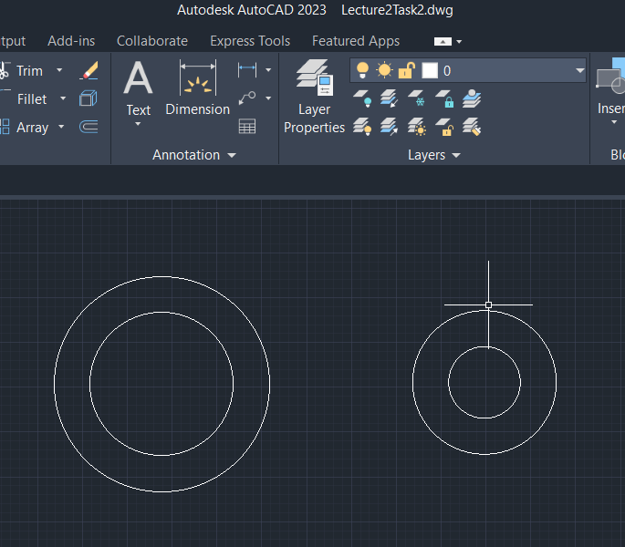

Figure: 4.1.1

step2: Right click the mouse button. Then select the tangent. Then select a line using Line tools then draw the lines from one circle to another circle.

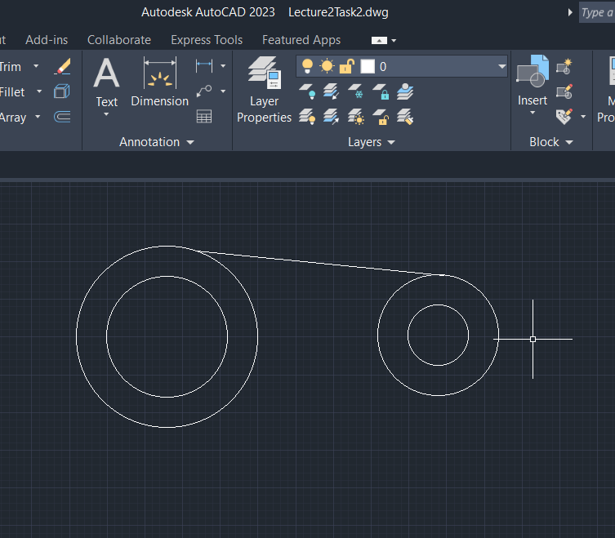

Figure: 4.1.2

step3: Measure the radius of all circle and distance between two circle using measuring tools.

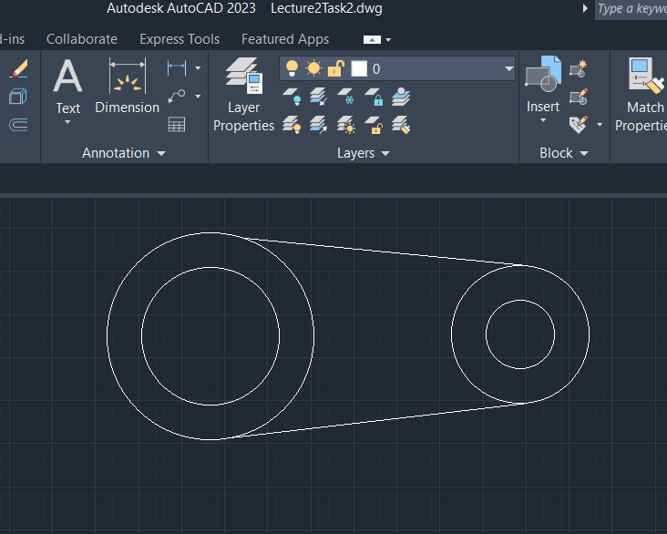

Figure: 4.1.3

**Lecture slide-3 Task-1:**

**Detailed steps to drawing of task2:**

Step1: Draw the two circle using the circle tools and the given radius respectivly. then determine the center of the two circle and again draw two circle from the center using the given radius.

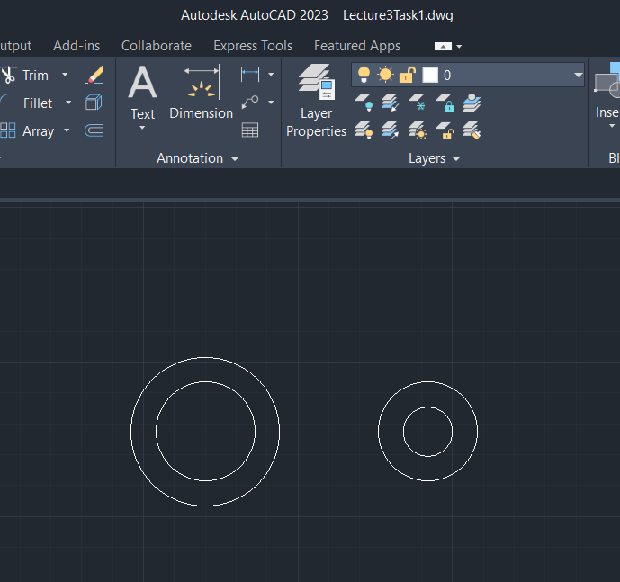

Figure: 4.2.1

step2: Right click the mouse button. Then select the tangent. Then select a line using Line tools then draw the lines from one circle to another circle. Then using trim tools and trim from the two outer circle.

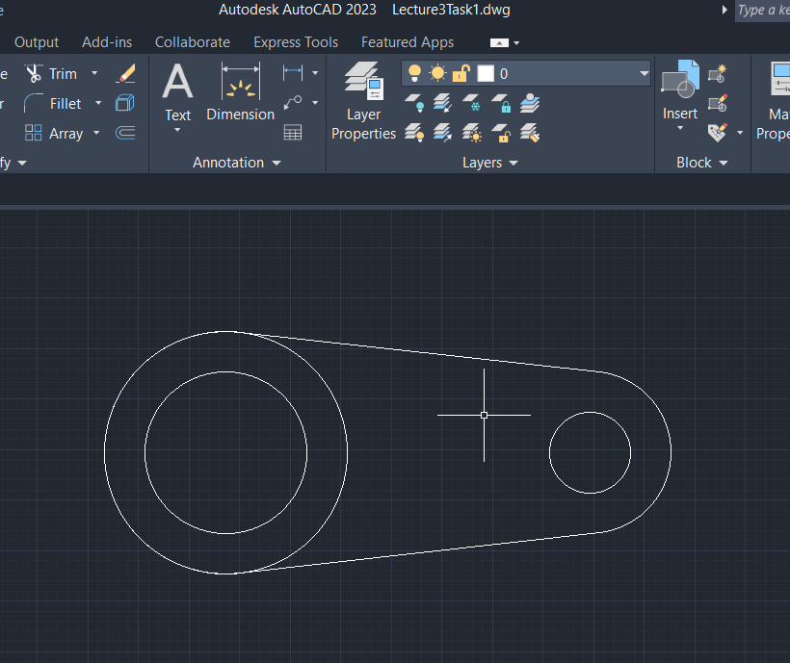

**Figure: 4.2.2**

step3: Measure the radius of all circle and distance between two circle using measuring tools.

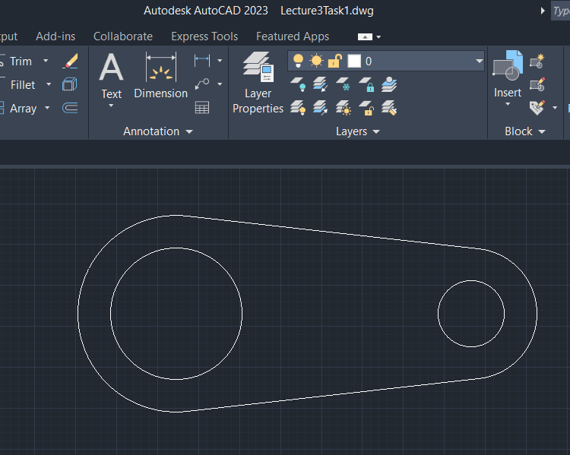

**Figure: 4.2.3**

**Lecture slide-3 Task-2:**

**Detailed steps to drawing of task3:**

Step1: Draw the outer polygon at first with side-length 20. Then determined the end point of five sided polygon.

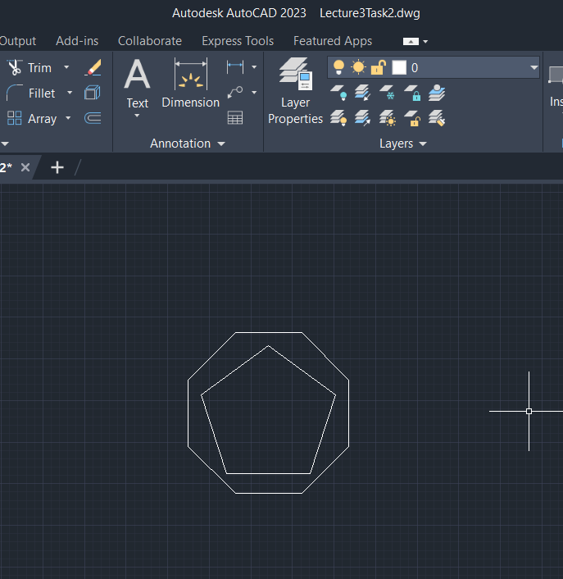

Figure: 4.3.1

Step2: Determine the center point of polygon. Draw the internal six-sided polygon from center point with radius 13. Draw the rectangle in top with height and width 14 and 20 respectively.

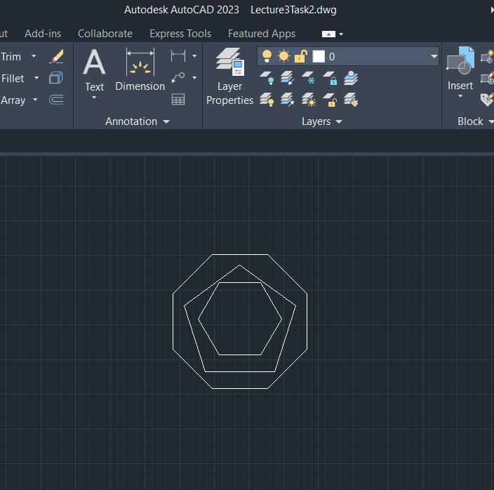

Figure: 4.3.2

Step3: Measure the length of all the polygon using respective tools.

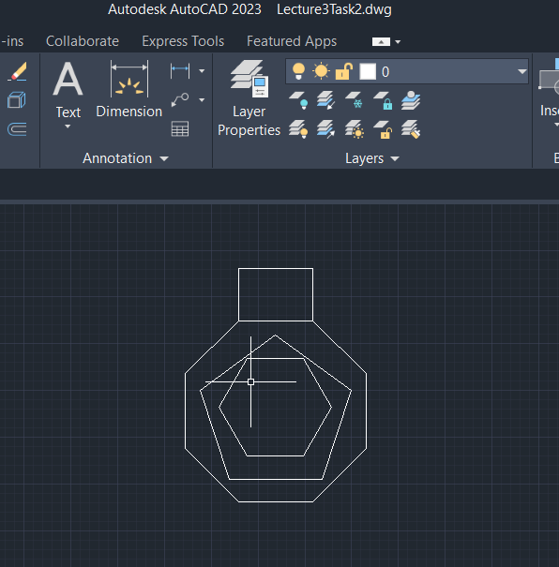

Figure: 4.3.3

**5. TEST RESULT / OUTPUT**

**Result of Lecture 2 task2:**

The result or output of the given task is given below. Where we can see that when I am goes to measure the radius it can measure successfully but the distance between two center points of different circles is not measure correctly. It is the drawbacks of this experiment.

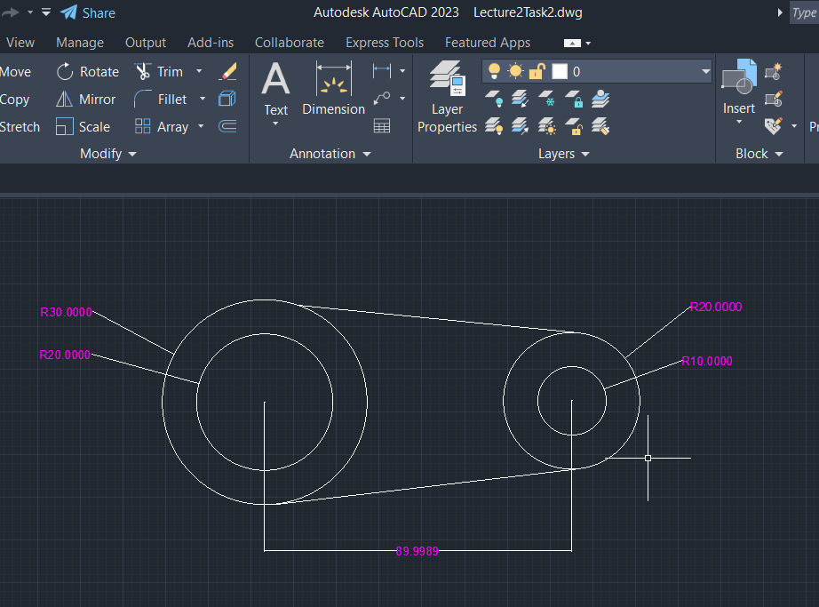

**Figure: 5.1**

**Result of Lecture slide-3 task-1:**

The result or output of the given task is given below. Where we can see that when I am goes to measure the radius it can measure successfully but the distance between two center points of different circles is not measure correctly. It is the drawbacks of this experiment. There is also a drawbacks because I am does not measure all the circle radius.

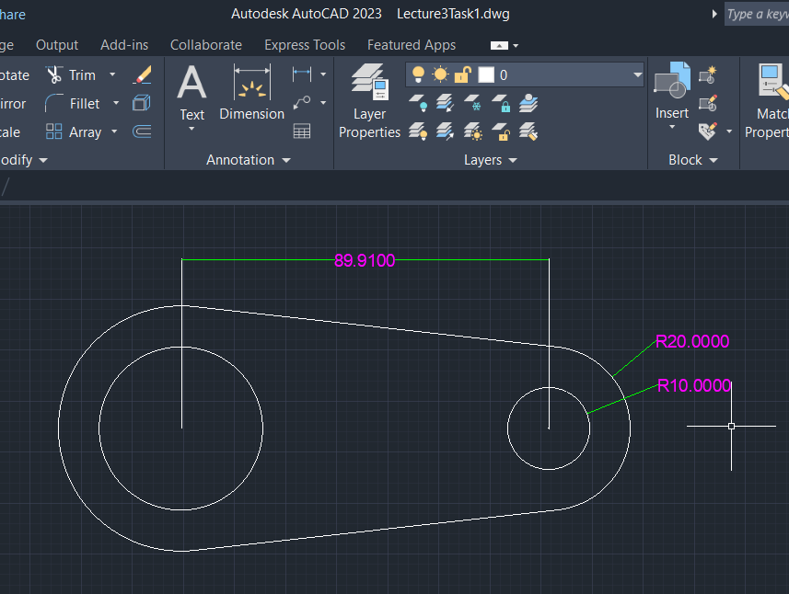

**Figure: 5.2**

**Result of Lecture slide-3 task-2:**

The result or output of the given task is given below. From the image we can clearly see that I am tried to draw the given task correctly and at the end I am success on my goal. So, the result in shown in figure is similar at the given task.

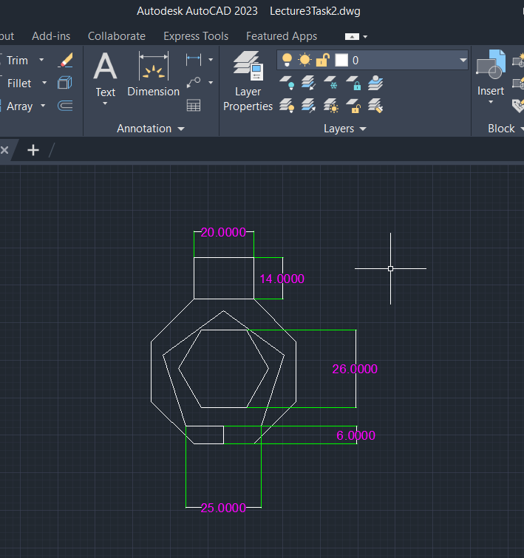

**Figure: 5.3**

**6. ANALYSIS AND DISCUSSION**

Based on the focused objective(s) to understand about the advance knowledge of 2D drawing and implement those to design a real life object. And the lab exercise made us more confident towards the fulfilled of the objectives. And in this experiment I am learn about some basic drawing tools and how to implement the given task using those tools. When I go to solved the given task I face some problem. But I am overcome this problem by analyzing in a long time. And finally my Lab Experiment-1 is done. This is all about of this lab experiment 1.